PROJECT DEVELOPMENT DOCUMENT
EduGenie – Google Gemini Powered Learning Assessment

1. Introduction
EduGenie is a Google Gemini powered learning assessment project designed to support students through AI-generated questions, interactive assessments and automatic performance feedback. The development phase converts the project design into a working application by implementing the user interface, backend services, Gemini API integration, assessment logic and result generation.
2. Development Objectives
- Develop a simple and user-friendly student assessment interface.
- Integrate Google Gemini to generate topic-based assessment questions.
- Implement backend APIs for assessment creation, submission and result processing.
- Calculate scores and present clear performance feedback.
- Create a modular structure that can be extended with additional subjects and topics.
3. Development Technologies
Technology | Purpose
Frontend – HTML, CSS, JavaScript | User interface and interactive assessment pages
Backend – Python / FastAPI | API development and application logic
Google Gemini API | AI-based question generation and learning feedback
JSON | Data exchange between frontend, backend and AI service
Database / Storage | Store student assessment and result information
VS Code | Development and project management environment
4. Development Process
Requirement Analysis: Identify student, assessment, question-generation and result requirements.
UI Development: Create login, assessment, question and result screens.
Backend Development: Build API endpoints and implement assessment processing logic.
Gemini Integration: Connect the application to Google Gemini and prepare structured prompts.
Testing: Test question generation, answer submission, score calculation and error handling.
Deployment Preparation: Organize configuration, dependencies and application files for execution.
5. User Interface Development
The frontend is developed to provide a clear workflow: student login → assessment setup → AI-generated questions → answer submission → score and feedback. The interface is designed to be simple so that students can focus on learning rather than navigation.
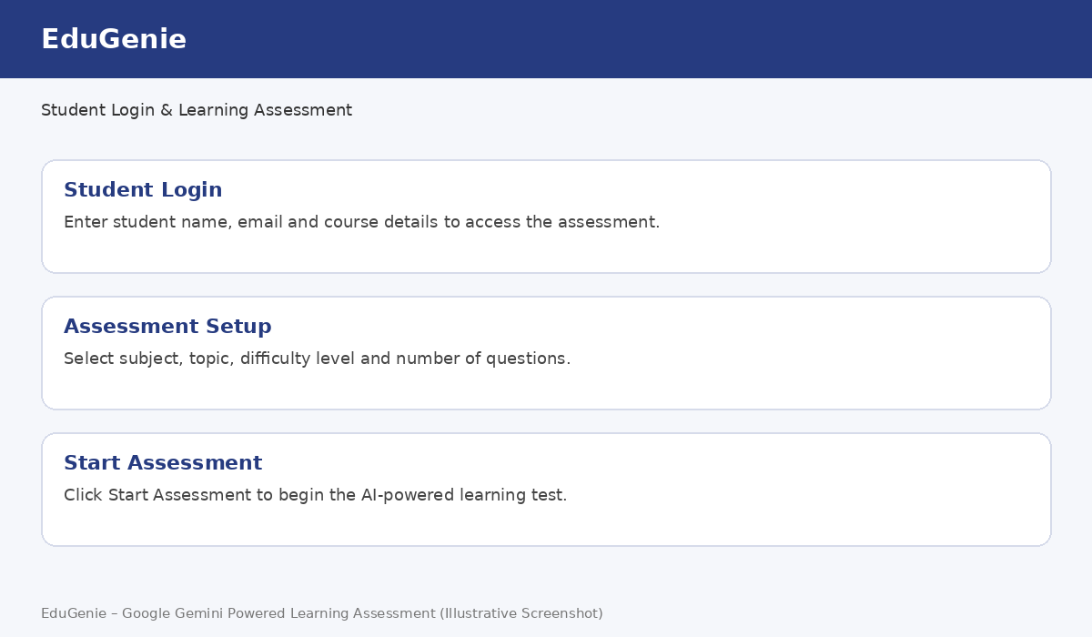
Figure 1: EduGenie login and assessment setup – illustrative screenshot.
6. Google Gemini API Integration
The Gemini integration is the core AI component of EduGenie. The application sends structured prompts containing the selected subject, topic and difficulty level. The returned AI content is parsed and converted into assessment questions. Input validation and response checking are used to reduce malformed or incomplete data.
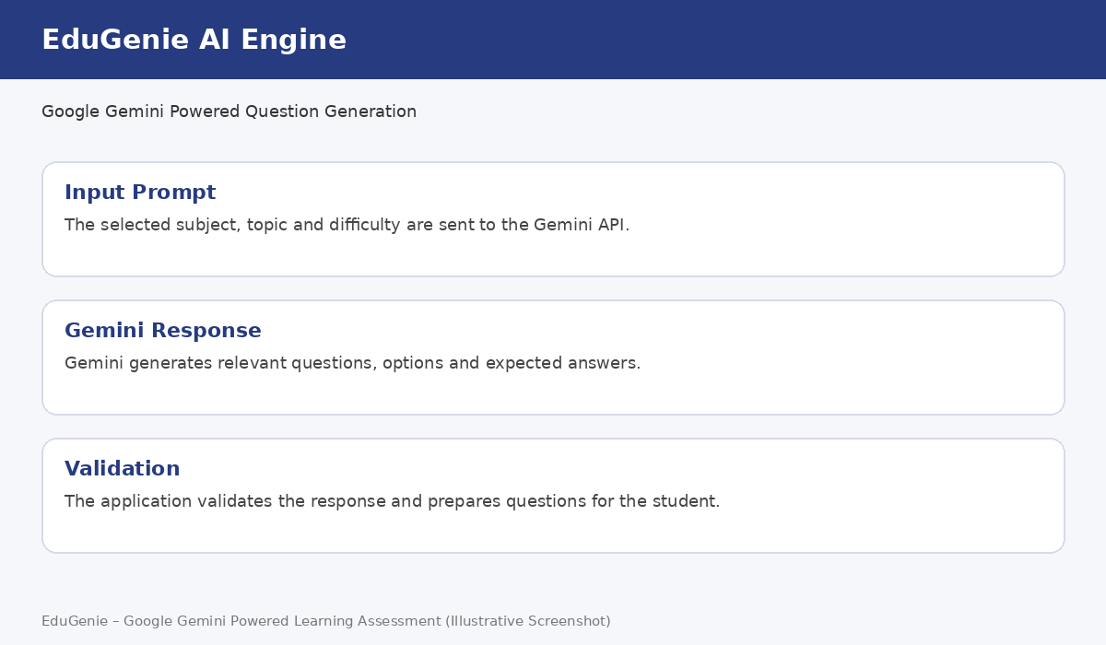
Figure 2: Gemini-powered question generation – illustrative screenshot.
7. Assessment Module Development
The assessment module displays one or more questions with multiple-choice options. Student responses are collected and submitted to the backend. The application maintains the assessment state until the student completes all questions.
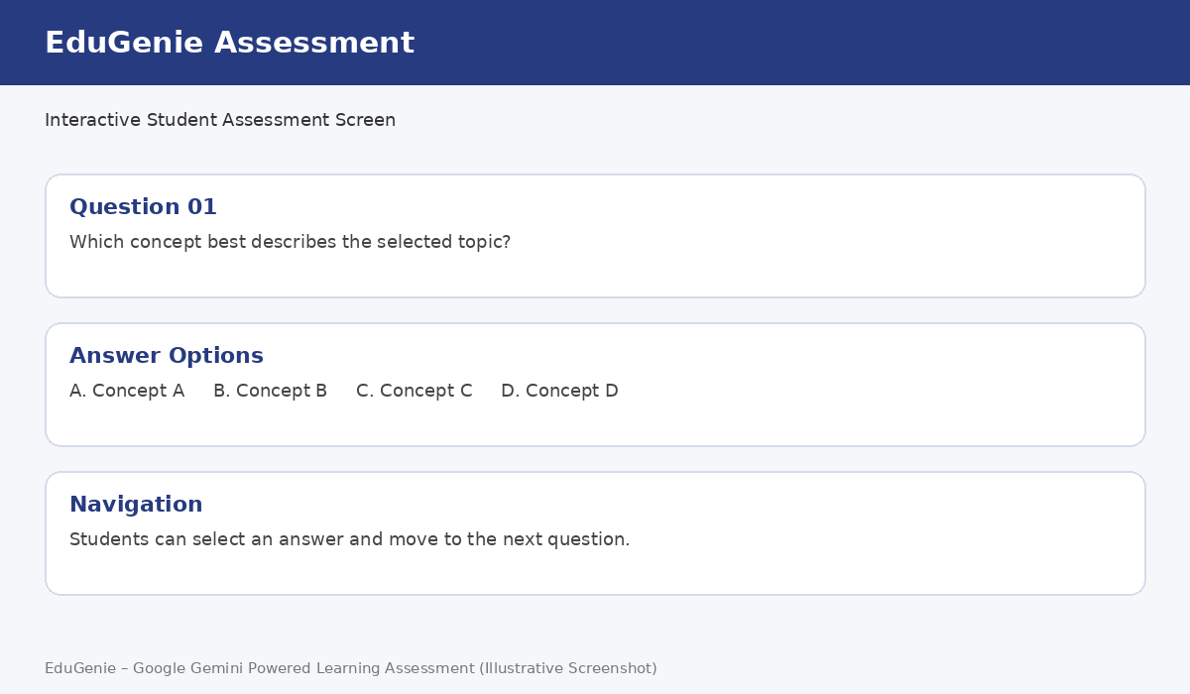
Figure 3: Interactive assessment interface – illustrative screenshot.
8. Result and Feedback Module
After submission, the backend evaluates the selected answers and calculates the score and percentage. The result screen presents the student's performance and can provide AI-assisted feedback based on the learning topic.
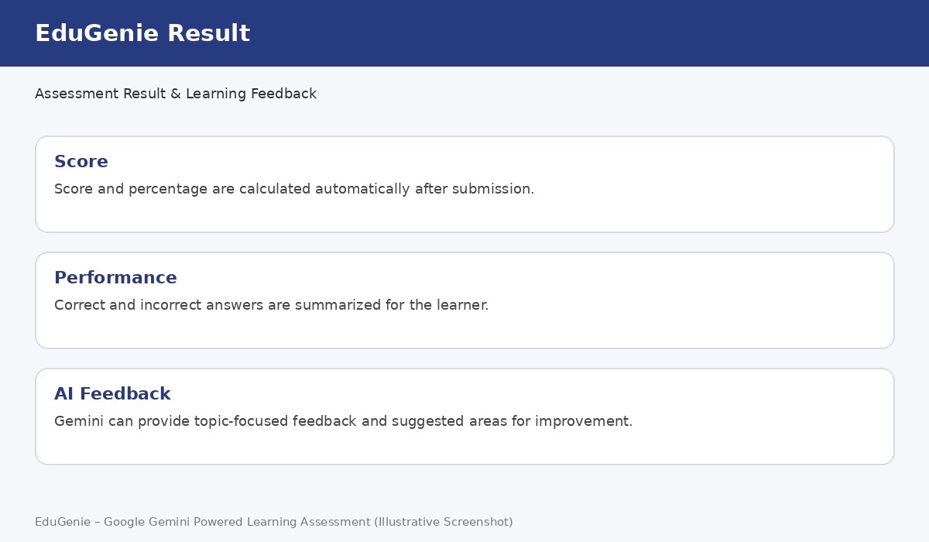
Figure 4: Assessment result and feedback dashboard – illustrative screenshot.
9. Backend Development Flow
- Receive assessment configuration from the frontend.
- Create a structured Gemini prompt.
- Send the prompt to the Gemini service.
- Validate and format the generated questions.
- Return questions to the frontend.
- Receive student answers and calculate the result.
- Return score, percentage and feedback to the result page.
10. Testing and Validation
- Verify that all input fields accept valid data.
- Check that generated questions follow the selected topic and difficulty.
- Test API responses and error handling when the AI service is unavailable.
- Verify answer submission and score calculation.
- Check the result page on different screen sizes.
11. Conclusion
The development phase of EduGenie brings together the frontend interface, backend services and Google Gemini AI to create an interactive learning assessment system. The completed modules provide a foundation for future features such as student progress tracking, personalized question difficulty, question history and expanded subject support.

